**Setup diagram**

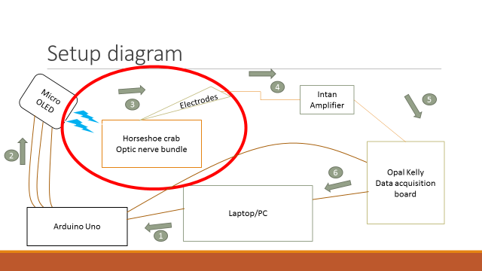

1. **Laptop/pc to Arduino Uno**

Arduino control code is on the following link: <https://github.com/arahangua/Horseshoecrab>

There are three codes:

1) Arduino code

1. Python code to control the Arduino
2. Parsing code to parse the output “arduino_log.txt” to generate the array variable(stimulation sequence).

**2)** **Arduino Uno to Micro-oled**

Connection scheme is also on the same link: <https://github.com/arahangua/Horseshoecrab>

To minimize the unwanted (EMF) noise, it is recommended to cover wires with aluminum foil.

Micro-oled is mounted on the 3d-printed holder. STL file is also on the github.

Micro-oled has a light wavelength of 450 ~ 500 nm which is still in the right wavelength region to stimulate the horseshoe crab optic nerve.

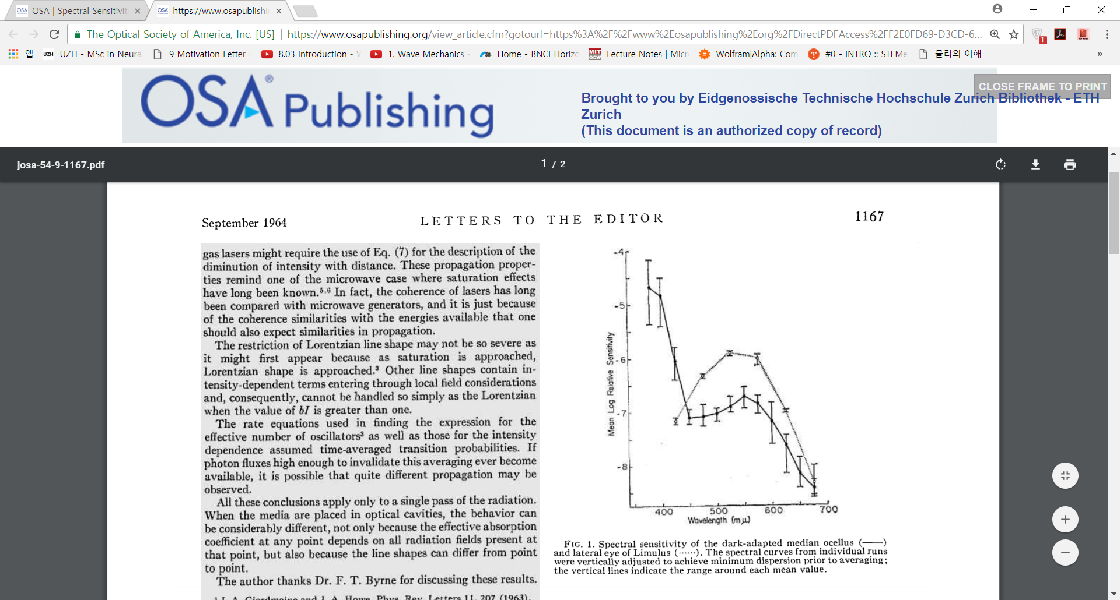

Abner et al. “Spectral Sensitivity Comparison of Lateral Eye and Ocellus of Horseshoe Crab”, 1964, OSA publishing

**3) Horseshoe crab optic nerve bundle to electrodes**

This part was not yet addressed. Initial plan was to use tetrode (electroplated with platinum) to try picking up signals from the bundle. Nevertheless, the guideline is to cancel out all the noise signals and especially, one must make sure that low frequency perturbation is contained so that the amplitude is less than 5~8 $μV$.

1. **Intan amplifier**

We were using 32 channel intan amplifier

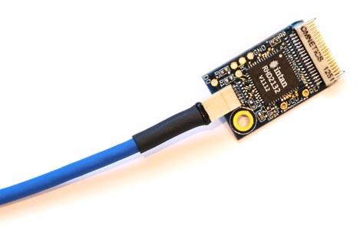

<http://intantech.com/RHD2132_RHD2216_amp_board.html>

1. **Opal Kelly data acquisition board**

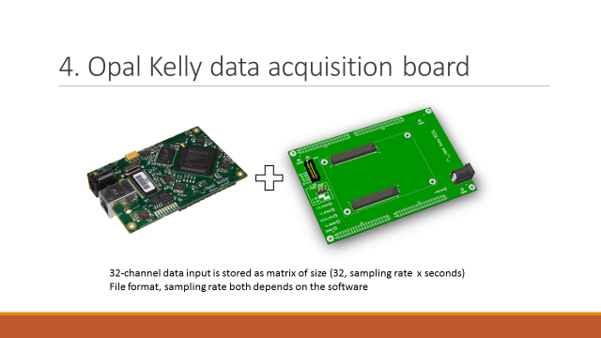

Opal Kelly data acquisition board is mounted on the break-out board. Exact pin matching scheme is also uploaded on the github. From Arduino board, whenever there is light stimulation it will send out digital trigger pulse. This pulse can be fed into one of the digital input pins on the breakout board.

1. **Opal Kelly to laptop**

There are two options for the data processing:

1. Intan software (“RHD2000interface”)
2. Open ephys (open source software, <http://www.open-ephys.org/>)